Producing Reports in Banner

To run reports in Banner from the Banner General Menu, enter the seven character report name in the Go To…field and hit Enter

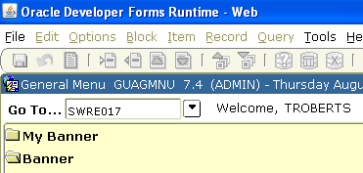

and you will be taken automatically to the Process Submission Controls (GJAPCTL) forms.

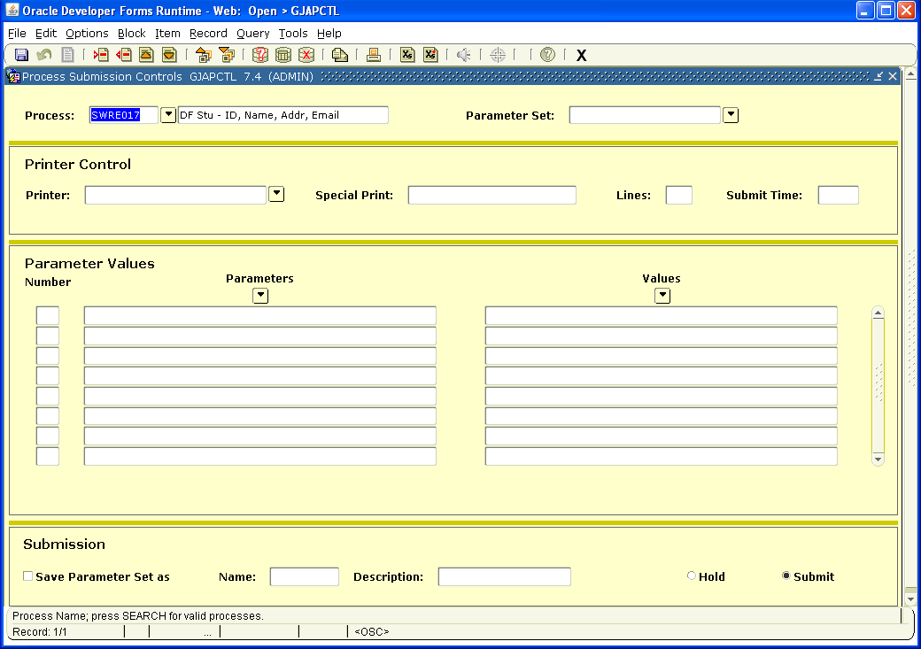

Next Block into the Printer Control field. Either select the printer to which you want the report printed or leave DATABASE in the field to get an electronic copy of the listing. (Note: Report listings are only available from reports that produce a listing. Some reports such as SWRE017 do not produce a listing – only a data file.) Next Block into the Parameter Values block and fill out the values appropriately for the data you require (see Parameter Values section below for additional assistance on this section.) Next Block to the Submission block and click on the diskette in the upper left hand corner (just under File) to run your report.

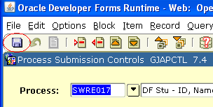

The auto hint at the bottom (gray line) will provide you with the job number for your report. If you selected DATABASE for your printer, see the following section ‘To get an electronic copy of the listing/Downloading report listing output to user’s PC’ for additional instructions.

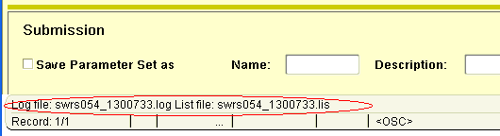

To get an electronic copy of the list/Downloading report listing output to user’s PC:
- Run report same as if printing it, except leave DATABASE in the printer block
- After saving to execute the report, click on Options from the title bar drop down menu and then click on ‘Review Output’..
- This brings up the form GJIREVO pre-filled with the report name and the job number. Click in the box directly to the right of the job number box. When it will let you into this File Name box, the report has completed (a good estimate is how long it takes when you run it to the printer from the time you’ve saved it to the time is starts printing.) Double click in this box.
- A box will pop up labeled ‘Available Files’. It will contain just the .lis and .log of the job just completed if you come here from the job submission form and double click after completion of your job. You will get a list of all runs of this report by you that are in the database if you come to GJIREVO directly or if you double click in the File Name box before your current job has completed. The most recent one should be the one highlighted.
- Select the file with the .lis extension - these are the reports (the .log file is just the record of the report run.) Then click OK at bottom center of the Available Files box.
- If you would like to save and/or print the file, click on Options from the title bar drop down menu and then click on ‘Show Document (Save and Print)’. This will open your document in a new browser menu and from there you can save the document and/or print your document.

Note: When you are finished with reports that you have run to the database, it is a good idea to delete them. From the GJIREVO form, select the report and then click on Options from the title bar drop down menu and then click on ‘Delete Output’.

Parameter Values

There are a variety of types of parameters. Some parameters are required and others are optional. Some parameters can be wild carded (meaning accepts all existing values) and some have to have a value provided. Some parameters are single occurrence, meaning only one choice may be selected per report run, and others are multiple occurrences, meaning multiple values may be selected for the report run.

To check what the types are of each parameter, click on the value field for a parameter and then check the notes area at the bottom of the Parameter Values section. In the example below you can see that the parameter Term Code is of type Character, Required, and is Single. This means a term must be provided and only one term can be processed per report run.
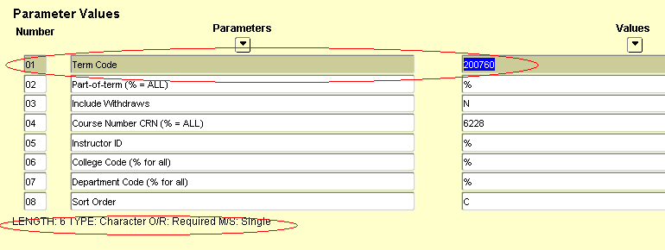

Next is an example of a multiple occurrences parameter - Course Number CRN in this example:
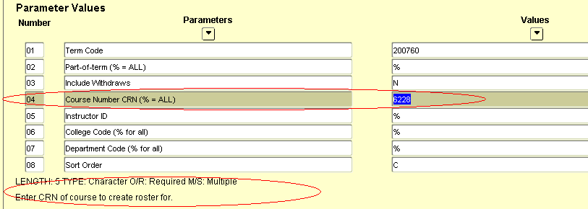

Parameter number 04 is the Course Number CRN parameter. One CRN is already enters in the example above of 6228. To request additional CRNs as part of this one run move to the 04 parameter line. Click on Record -> Insert and a new line will appear in the Parameter Values section below your current line.
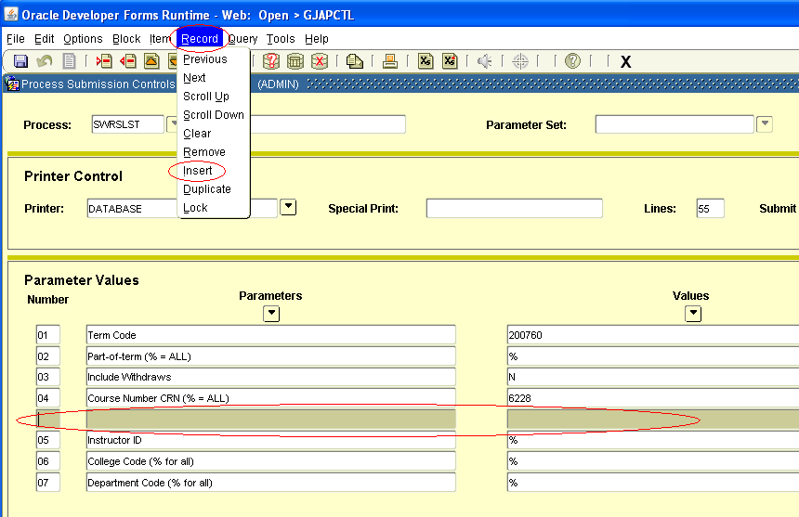

Your cursor should already be in the number field of the new empty line. Type in the parameter number you would like an additional value for – in this case 04 – and the Parameter field will fill in for you and the cursor will move into the Values field. Enter the next CRN. This can be repeated as needed.

Additional notes on Parameter Values

For Parameters that have Banner coded values, typically in the form of a validation table, these can be accessed to select the codes desired by clicking on the drop down box below Values while having the cursor in the Values field for which you want to review the code values. In the example, the cursor is in the Values field of the College Code parameter.

Click on the Values drop down button.

The College Code validation table (STVCOLL) will be presented for review of the codes and descriptions for selection.
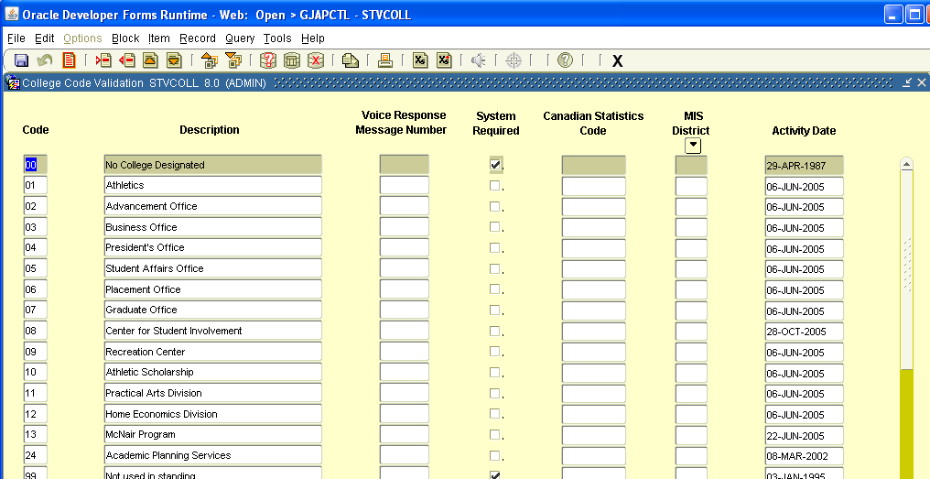

Double clicking on a code from the list will select the code and return you back to the job submission form. You can also click on the X (normal Banner form close process) and return back to the job submission form without a selected code.
Instructions for Running Selected Reports

PRINTING A CLASS ROSTER
(TRUMAN-DESIGNED REPORT)
Instructions prepared 8-20-03

Using Direct Access or Go, go to SWRSLST

Next block

Double-click in the Printer field and find your printer (this is a landscape report--utilize the printer designation for your area that has an “l” at the end).

Next block

Enter the term code in the Value field in Line 01 (e.g. 200360 is Fall 2003).
Leave the Value in Line 02 as “%” to obtain rosters for all parts of term (blocks), or change to the appropriate part of term code (1=full term; 2=first half; 3=second half, etc.).
Leave the Value in Line 03 as “N” unless you wish to include names of students who have dropped the course, then change this value to “Y.”

Decide which rosters you wish to run by entering one of the following values:

  - Enter the Course Reference Number in the Value field in Line 04 OR
  - Enter the Instructor ID Number in the Value field in Line 05 OR
  - Enter the College Code for your College/School in the Value field in Line 06 (e.g. Science = SC) OR
  - Enter the Department (Discipline) Code in the Value field in Line 07.

Decide the sort order. The default is “C” College/Instructor/Subject/Course/Section. The other option is “S” Subject/Course/Section.

Next block

Click on the Save icon in the horizontal toolbar
Class Rosters should print to the designated printer.
PRINTING INSTRUCTOR SCHEDULES
(TRUMAN-DESIGNED REPORT)
Instructions prepared 8-20-03

Using Direct Access or Go, go to SWRASGQ

Next block

Double-click in the Printer field and find your printer (this is a landscape report--utilize the printer designation for your area that has an “l” at the end).

Next block

Enter the term code in the Value field in Line 01 (e.g. 200360 is Fall 2003).

Leave the Value in Line 03 as “%” to obtain instructor schedules that include all parts of term (blocks), or change to the appropriate part of term code (1=full term; 2=first half; 3=second half, etc.).

Decide which Instructor Schedules you wish to run by entering one of the following values:

  - Enter the Instructor ID Number in the Value field in Line 02 OR
  - Enter the College Code for your College/School in the Value field in Line 04 (e.g. Science = SC) OR
  - Enter the Department (Discipline) Code in the Value field in Line 05.

Next block

Click on the Save icon in the horizontal toolbar (do not click “Save Parameters” at the bottom of the form)
Instructor Schedules should print to the designated printer.

SCHEDULED SECTION TALLY

Using Direct Access, go to SWRTALY

Next block
Double-click in the Printer field and find your printer. Be sure to use the printer that has an “l” at the end for this landscape report (e.g. “mathdivl” for the Math & CS Department, Landscape format).

Next block
Enter the appropriate term in the Value in Line 01 (e.g. 200340 for Summer 2003, 200360 for Fall 2003, etc.). Only one term can be entered for each report run.
Leave the Value in Line 02 as “%”
Leave the Value in Line 03 as “2”
Leave the Value in Line 04 as “M”
Change the Value in Line 05 to your 2-letter College/School Code

AS College of Arts & Sciences
EH School of Health Sciences and Education
JI Junior Interdisciplinary Seminar Program (JINS Courses)
LM Libraries & Museums
PD Professional Development
RC Residential Colleges
SA Study Abroad
SB School of Business
ZZ Inter-Divisional

Leave the Value in Line 06 as “%” if you wish to print all subjects or disciplines. If only one discipline is desired, enter the discipline code (e.g. “MATH” for only math courses, not to include STAT and CS).

Next block
Click on the Save icon in the horizontal toolbar (do not click “Save Parameters” at the bottom of the form)
The Scheduled Section Tally Report should print to the designated printer.

